12.66: a) The energy the satellite has as it sits on the surface of the Earth is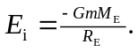
The energy it has when it is in orbit at a radius 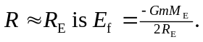 The work needed to put it in orbit is the difference between these: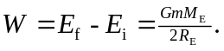
b) The total energy of the satellite far away from the Earth is zero, so the additional work needed is 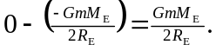
c) The work needed to put the satellite into orbit was the same as the work needed to put the satellite from orbit to the edge of the universe.

